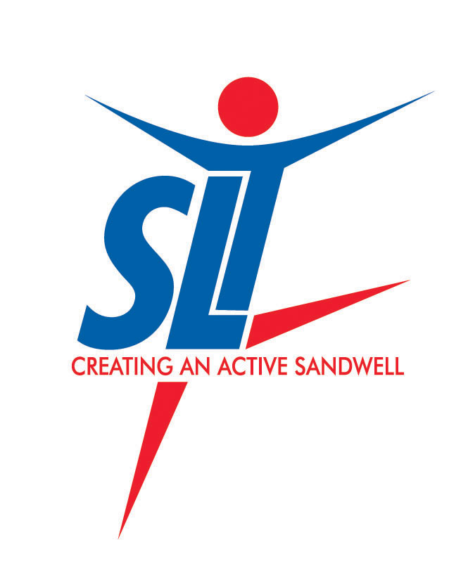
Sandwell Leisure Trust Holiday Camp Registration Form
Page 1 of 2
Young Persons Details
Surname | First name
Address
Postcode | Date of Birth
Gender | School

Parent/Guardian/Carer Contact Details
Name | Relationship to young person
Telephone | Mobile
Alternative Contact | Email

Would you like your child / young person to remain with the activity coach until yourself or a responsible adult collects them?

Please tick and complete the section below that applies
I authorise my child / young person to make their own way home from the holiday camp or to wait in the leisure centre reception area unsupervised until an adult can collect them
I would like my child / young person to be supervised by the sports coach until they are collected by an adult (must collect by 4:10pm latest)

Password to be used for collecting young person__________________________

No young person will be released into an adults care without the password given

During the course of the holiday camp, there may be times when we may be using photography or videoing. SLT requests your permission for this

Do you consent to SLT taking and using your young person’s image in publications and displays borough wide and on the SLT and SMBC websites and social media including Facebook and Twitter? | YES ◻ NO ◻

PLEASE TURN OVER & COMPLETE FURTHER INFO AND SIGN DECLARATION

Sandwell Leisure Trust Holiday Camp Registration Form – Page 2 of 2

I hereby give 'explicit consent' to provide details of personal medical conditions for participation in this activity with Sandwell Leisure Trust. In doing so I also authorise Sandwell Leisure Trust to use this information deemed as appropriate and relevant in accordance with the Data Protection Act.

Does the young person have any medical conditions, allergies, sensitivities to medication etc?

YES ◻ NO ◻ If yes, please detail:

Does the young person have a disability or any specific needs we should be aware of?

YES ◻ NO ◻ If yes, please detail:

I would best describe the young person’s ethnicity as: White ◻ Black/African/Caribbean ◻
Asian ◻ Mixed/Multiple Ethnic Groups ◻ Rather Not Say ◻
Other:


The information held on this registration form will be held and processed by Sandwell Leisure Trust (in partnership with Sandwell MBC), for the purpose of Holiday Camp activity registration in accordance with the Data Protection Act 1998. This information may be shared within Sandwell Leisure Trust for emergency purposes and to notify you of relevant products and services. We ask that you please notify us immediately of any changes to your personal information. You can request a chargeable copy of any personal information held about you by completing a 'Subject Access Request Form' available from Sandwell Leisure Trust.

Parent/Guardian/Carers Declaration

In the event of an emergency:
I agree / disagree to _______________________(name of young person) being given any medical, surgical or dental treatment, including general anaesthetic and blood transfusions as considered necessary by the medical authorities present.(please delete as appropriate)

I, the undersigned, agree to inform SLT with the minimum of delay should any change of circumstances occur in relation to the information held on this form.

I further understand that if I do not collect the young person from the camp within a reasonable amount of time after the end of the activity, that SLT reserve the right to contact the appropriate local agencies. SLT also reserve the right to charge an additional £5 fee if my child is not collected from the coaches within 10 minutes of the session finishing.

Signature (Parent/carer)_________________________________ Date___________________

